THE CORE THEATRE SOLIHULL TICKETING & PUBLICITY FORM

Complete and return this form in order for us to set up and sell tickets and publicise your event.
ABOUT YOU (This also means Group / Club / Company / Society etc. as appropriate)

NAME___________________________________________________________________________

Address__________________________________________________________________________

Postcode ____________ e-mail____________________ Ticket Contact_________________

Daytime Tel. No:____________________________ Mobile________________________________

ABOUT YOUR TICKETS (This info will be shown on your tickets)

TITLE of Show / Event _____________________________________________________________

Show presented by (optional i.e. Promoter/Society) ______________________________________

Second line text (optional) ___________________________________________________________

Venue (Theatre/ Studio other) _______________________________________________________

Concession prices: Where offered MUST include: - Senior 60+, Student, Unwaged, Disabled & Child at the same reduced price (except optional different child price see * in box below).
You can add your own (i.e. your own members concession) if you wish, please state it here:-

Similarly Group Booking discount is optional but where selected, 1 free in 10 is the only group booking offered. Do you want group discount? Circle here: YES PLEASE / NO THANKS.

Date tickets go on sale to the general public ____________________ (allow 10 days’ notice)
Day | Date | Start Time | Full Price | Concession | *Child | Office code
Monday
Tuesday
Weds
Thursday
Friday
Sat mat
Sat eve
Sun mat
Sun eve
Show running time: _____mins. Interval (always 20mins) Yes / No at ____: ____am/pm

If you prefer to sell your own, you MUST use our printed tickets. Tickets required by ________

Do you need free guestlist tickets reserved? YES / NO how many? _______ which row?______

ABOUT YOUR SHOW This information helps us sell your tickets using print/website and should be valid, correct and true. Please check carefully all info including writers, songs, content, suitability etc. as improper advertising can lead to complaints and refunds. You must notify us of any amendments as soon as you become aware. i.e. change of support act/performer or content.

SHOW INFORMATION. Brief description to include; suitable age range, any author/composers, brief plot, hit songs, swearing, nudity or strong content. Use a separate sheet if you need to explain.

Suitable for ages: (when left blank we will assume ANY age)

EXTRA BROCHURE INFO: Tell us more about cast details/websites that you are happy to be given to your customers upon request or in our brochure/website. Detailed content might include playlist or biog etc. You may supply this on an extra sheet, flyer or leaflet or email it to us.

PRINTED PUBLICITY: Send print to the venue as early as possible – we don’t make any guarantees regarding display. For overprinting please use this info:- The Core Theatre. Box Office 0121 704 6962. www.thecoretheatresolihull.co.uk please do not use Solihull Library Theatre.

IMAGES & LOGO: We need a good quality image, supplied as a jpeg/tiff file emailed to diane.scruby@solihull.gov.uk or thecoretheatre@solihull.gov.uk clearly titled with show title/date.

OTHER CONTACTS (if different from those you have given overleaf)

Membership contact for people interested Marketing contact regarding print, pics or
in joining your group/classes (if applicable). other publicity matters (if applicable).

Name______________________________ Name______________________________

Daytime Tel_________________________ Daytime Tel_________________________

WEBSITE & ONLINE SALES
We may promote your show on our website unless you write NO here........
We may promote and sell your tickets ONLINE unless you write NO here........

Please read all the accompanying information before signing this form as you are agreeing to our website, ticketing & publicity terms and conditions. Keep info sheets for your future reference. Please speak to staff if you are unsure or have queries regarding your show.

Signed _______________________________ Print Name_________________________________

Title Date
TERMS & CONDITIONS FOR HIRERS – SEATS, TICKETS & PUBLICITY

These terms and conditions apply to all performances at The Core Theatre Solihull (formerly Solihull Arts Complex) and where appropriate, to events/tickets being sold for other venues or promoters.

SEATS
- The total available seats is 336 and cannot be exceeded. No other persons can remain without a seat nor sit/stand in aisles or along the back wall; this is a legal Fire Regulation requirement and is strictly adhered to at all times.

- Back row seats no longer have restricted legroom as shown in seating plan (except P7).

- Seats P14 – P17 form part of the permanent sound desk and these seats are always off-sale.

- For wheelchairs, seats A1–A4 & A14–A17 remove in pairs. Maximum wheelchairs 3 each side (and no other seats). Seats A5–A13 remove in threes, maximum wheelchairs here 6 (and no other seats). When one block of 3 seats are removed for a wheelchair a single loose seat can inserted adjacent. Both the front row (and overall) seating capacity will be reduced for the first and each subsequent wheelchair booking. Group selling their own tickets MUST inform Box Office of all wheelchair bookings on Row A to check their sale is correct.

- Theatre shows are reserved seating i.e. A1, B2, etc. but events in the Studio are unreserved seating i.e. 23, 24 etc. and cannot be pre-ordered or reserved by any means.

TICKETS
- Child ticket sales apply to children aged 18 months up to 16 years. Student ticket concessions apply to those in full time education. Unwaged refers to those on Jobseeker Benefits whilst Senior concession applies to those aged 60+. Proof may be requested for any concession either at box office or upon entry to the show.

- Carer seats. These are for carers of people who cannot access or exit the building unaided in an emergency situation, this is usually for wheelchair users and people who are registered blind, but can also include people with other conditions. Carer seats will show a zero value on the Hirers Final Show Report. Carers should obtain and show their CARERS card.

- Groups bookings should be carefully managed by hirers and/or Box Office to ensure smooth arrival/exit and appropriate seating for the groups size and mobility.

- There is a 'No exchange or refund policy' on all tickets. This is mentioned at point of sale both within our office and online. Hirers selling tickets themselves must give buyers this correct info, particularly regarding refunds and wheelchairs etc.

- If show is cancelled by hirer, they will refund any tickets they have sold themselves whilst the venue will refund any tickets sold through Box Office at a refund fee per ticket (currently £2 + vat). No booking fees can be refunded for tickets sold online. Hirers should check the venues:- Hire Cancellation Policy, Refund Policy and Cancelled Show Policy prior to booking.

- Hirers should book/reserve their own tickets before release to public. Agency ticket requests should be on Agency Forms or using the online agencytickets@solihull.gov.uk

- Ticket limiting (i.e. max. 4 per person) is possible but repeat callers cannot be monitored. Where shows are sold online they are limited to a maximum of 9 tickets per transaction.

- Staff cannot 'manage' guest lists for hirers, artists, or promoters, but are happy to assist.

- Hirers MUST use venue printed tickets, no other ticketing is allowed within this venue.

- Tickets cannot be put on sale until a signed HIRE CONTRACT has been received by the Venue Hire staff to ensure that the show date is accurate and deposit paid.

PUBLICITY
16 When we are selling tickets as an AGENT, e.g. either on behalf of a hirer or for shows at outside venues, this may be acknowledged in any publicity we produce, online or within the venue. Our responsibility is limited to the price of the ticket and excludes other fees/charges.

17 Brochures are produced in early May and late November/December. Return this completed form in good time to ensure get your show on sale as early as possible. The venue retains final control on brochure and website entries - proofs are not supplied and text/images supplied by Hirers may be amended or cropped without reference or permission. Some events are excluded from the brochure so check with staff if you are unsure – hire of the theatre does not guarantee entry into the brochure where little or no public interest is expected i.e. dance schools, clubs etc. Website pages are free for all shows.

Hirers should call Box Office on 0121 704 6962 during normal office hours with any queries, or if your query remains unresolved, contact the Marketing Manager on 0121 704 6979.

By signing you are deemed to have read and agreed to the contents relating to your own event. Failure to read this form and make appropriate checks regarding these terms and conditions could result in errors and complaint leading to refunds/charges for which the venue cannot be held responsible and will be passed onto the Hirer or Promoter.

SEATING PLAN FOR THEATRE.
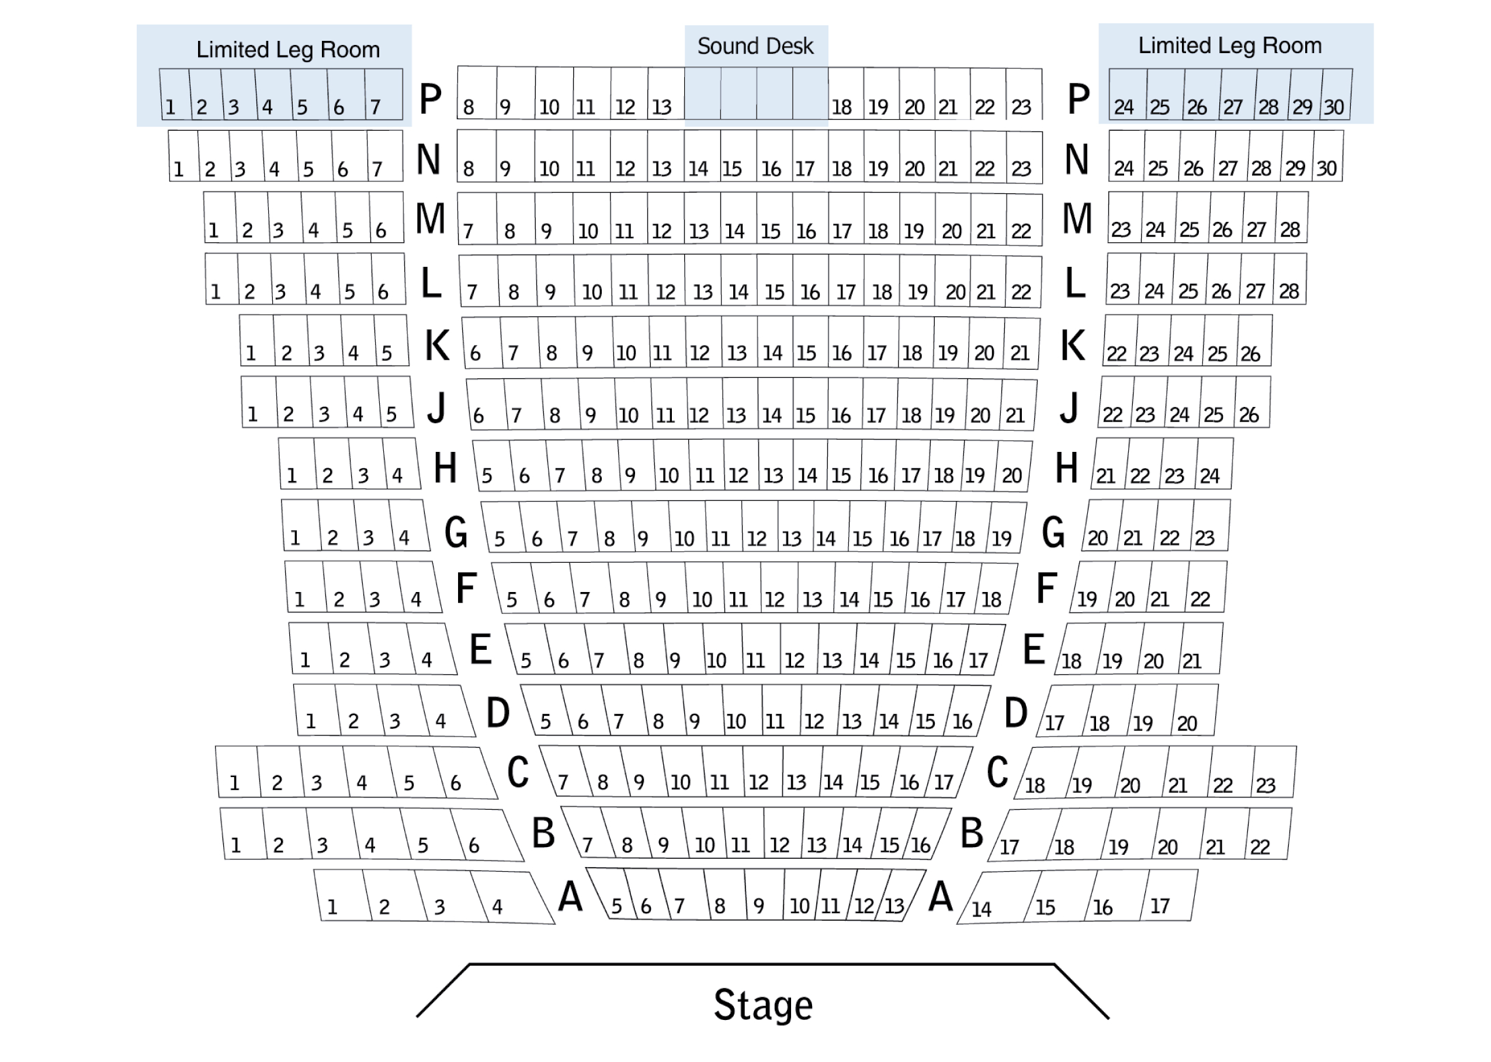
H/hire forms/ticket & publicity form.doc Last amended 23/03

