TICKETING & BROCHURE ENTRY REQUEST FORM
Complete this form if you need tickets printing for your show, if you wish us to sell your tickets
and/or if you wish to advertise your event in Solihull Arts Complex brochure (subject to agreement).

ABOUT YOU (This also means your Group / Club / Company / Society etc. if appropriate)

NAME___________________________________________________________________________

Address__________________________________________________________________________

Postcode _____________ Fax__________________ e-mail_________________________________

Contact re: ticketing (if different)______________________________________________________

Daytime Tel. No:____________________________ Mobile________________________________

ABOUT YOUR TICKETS (This info will be shown on your tickets - where required)

TITLE of Show / Event _____________________________________________________________

Show presented by (optional i.e Promoter/Society)_______________________________________

Second line text (optional)___________________________________________________________

Venue (Theatre / Studio / other) _______________________________________________________

Concession tickets (ie. reduced prices) are not compulsory but if you do choose to offer them they MUST include:- Senior 60+, Student, Unwaged, Disabled & Child. Concessions prices should be identical (except optional child price see * in box below) plus you can add your own (i.e. staff) if you wish, please state it here.

Similarly a Group Booking discount is optional but where you do choose it, 1 free in 10 is the only group booking offered. Do you want group discounts? Circle YES PLEASE / NO THANKS.

Date tickets go on sale to the public ___________ (allow 10 days notice )
Day | Date | Start Time | Full Price | Concession | *Child | Office code
Mon
Tues
Weds
Thurs
Fri
Sat mat
Sat eve
Sun mat
Sun eve
For Office use: A/C code (l/case) VAT? Yes / No

Show running Time: _____mins with an interval (always 20mins) Yes / No at ____: ____am/pm

If you prefer to sell your own, you MUST use our numbered tickets. Tell us what date you need them ________ If you want only certain tickets, this is called AGENCY, please discuss with Box Office.

Do you need free guestlist tickets reserved prior to sale? YES / NO how many?____which row?___

ABOUT YOUR SHOW This is the information our staff will need to help sell your tickets.

If you book the venue some time in advance you may not have accurate show details or content needed to advertise the show correctly. However we will still need 'basics' before the show can go on sale so tell us below what you know and tick below that you will supply further details later. Inaccurate info given can result in refund requests by disappointed customers so please don't 'guess'.

Details will be supplied nearer the date, I will keep you updated for brochure/website (tick)

SHOW INFORMATION. Write a brief description for customers including suitable age range, any author/composers, brief plot, hit songs etc. TELL US here of any swearing or nudity etc.
Use a separate sheet if you need to.

Suitable for ages: (where no range is given here we will assume ANY age)

EXTRA BROCHURE INFO Include here also cast details/websites that you are happy to be given to your customers upon request or in our brochure/website. Detailed content might include playlist or biog etc. Please supply this on an extra sheet, flyer or leaflet if you wish or email it with your images.

Picture/image details We will need a good quality image for our brochure, preferably supplied on disc or jpeg or tiff file emailed.(actual photo could be scanned. Email images, properly titled with your event title and date to dfitzpatrick@solihull.gov.uk. Please see attached info 18 for cost details.

OTHER CONTACTS (where applicable and if different from overleaf)
Membership contact for people interested Marketing contact regarding print, pics or
in joining your group/classes (if applicable). other publicity matters (if applicable).

Name______________________________ Name______________________________

Daytime Tel_________________________ Daytime Tel_________________________

WEBSITE & ONLINE SALES
We reserve the right to include this show on our website unless you write NO here …………………

We may offer your tickets for sale ONLINE in addition to our normal Box Office ticketing for which your customers will pay a small fee. If you do not wish this sales option state NO here………………

Please read all the accompanying information before signing this form as you are agreeing to our ticketing & publicity terms and conditions. Detatch the info sheets attached and keep safe for your future reference. Please speak to staff if you are unsure or have any queries regarding your show.

Signed _______________________________ Print Name_________________________________

Title Date

H/hire forms/ticket printing Request form.doc

ADDITIONAL IMPORTANT INFORMATION ABOUT TICKETS FOR HIRERS

All performances at Solihull Arts Complex which are available to the public, will be subject to the following ticket selling system.

- The total available seats is 336 and cannot be exceeded. No other persons can remain without a seat nor sit/stand in aisles or at the back, this is a legal requirement for Fire Regulations.

- Child ticket sales apply to children aged 18 months up to 16 years. Student ticket concessions apply to those in full time education. Unwaged refers to those in receipt of benefits whilst Seniors concession applies to those aged 60+. Proof may be requested for any concession.

- Back row seats P1 – P7 and P24 – P30 have restricted legroom, whenever these are sold customers must ALWAYS be told these seat are narrow and may be uncomfortable for some.

- Seats P14 – P17 form part of the permanent sound desk and these seats are off-sale.

- For wheelchairs, seats A1–A4 & A14–A17 remove in pairs. Maximum wheelchairs 3 each side (and no other seats). Seats A5–A13 remove in threes, maximum wheelchairs here 6 (and no other seats). When one block of 3 seats are removed for a wheelchair a single loose seat can inserted adjacent. Both the front row (and overall) seating capacity will be reduced for the first and each subsequent wheelchair booking. Group selling their own tickets MUST inform Box Office of all wheelchair bookings to check correct number of remaining seats.

- It is part of our 'Access for All' policy that registered disabled or wheelchair users may request a FREE Carer ticket to enable them to attend any show at this venue. Blue Door Access should be booked at least 2 weeks in advance of show. Please ask for leaflet or check on website for details of what these include. Carer seats will count as 'Comps' on hirers Final Show Report.

- There is a 'No exchange or refund policy' on all tickets. Hirers selling some tickets themselves must give buyers the correct info, particularly regarding refunds, legroom, wheelchairs etc.

- If show is cancelled by hirer, they will refund tickets they have sold themselves whilst the Arts Complex will refund all tickets sold through Box Office and re-charge the current refund fee per ticket (currently £2 + vat) to the hirer. It is suggested that Hirers may wish to request a copy of this venues:- Hire Cancellation Policy, Refund Policy or Cancelled Show Policy.

- When we are selling tickets as an AGENT, e.g. either on behalf of a hirer at this venue, or for shows at outside venues, this may be acknowledged in any publicity we produce or within the venue. Our responsibility is limited to the price of the ticket.

- Hirers need to book/reserve their own tickets before release of general ticket sales. Where possible ticket secretaries or promoters should email their requests to Box Office and any regular collection dates/times should be pre-agreed with Box Office staff in advance as staff have the right to delay agency requests during very busy office periods. Agency ticket requests should be on a special Agency Form and seating plans are available.

- Ticket limiting (ie max 4 per person) is possible but repeat callers cannot be monitored.

- Staff cannot 'manage' guest lists for hirers, artists, or promoters, but are happy to assist.

- Hirers MUST use Arts Complex tickets, no other ticketing is allowed within this venue.

14 Theatre shows are reserved seating ie A1, B2, etc but events in the Studio are unreserved seating ie 23, 24 etc and no particular row/area can be pre-ordered or reserved by any means.
15 Tickets will not be put on sale until a signed HIRE CONTRACT has been received by the Operations Team who handle bookings and hires. This is to ensure that the date of your show has been accurately agreed by all parties with correct details and deposits paid.

- Our brochures are mailed around August and December each year. If your event is included please return forms in good time to ensure your tickets are on sale by this date. Events on sale will be displayed on the venues website (events list) unless you have specified not to.

- Please note the venue retains final control on all brochure entries - proofs are not supplied and text/images supplied by you may be cropped without your permission.

- Commercial or full week hirers have a brochure entry included within their hire fee. Brochure entries cost £50 + vat for everyone else which is paid at the final invoice NOT in advance.

- Some events, including dance/stage schools, are excluded from inclusion in our brochure due to space limitations. The venue retains full control so please check your event suitability.

Our Box Office is here to help you, if you have any queries or concerns whatsoever, please contact them on BOX OFFICE 0121 704 6962 to seek advice. Box Office opening hours are:- Monday to Friday 10am-5pm - Saturday 9.30am-5pm, then 6-7.45pm in the foyer when there is a show on.

If your query remains unresolved please contact the Marketing Manager on 0121 704 6979.

This form has been given you for your advice and information. By completing and submitting this form for your event you are deemed to have read and agreed to the ticketing terms and conditions. Failure to read this form in connection to your own event could result in financial loss or ticketing errors and/or refunds for which the venue cannot be held responsible

SEATING PLAN FOR THEATRE.
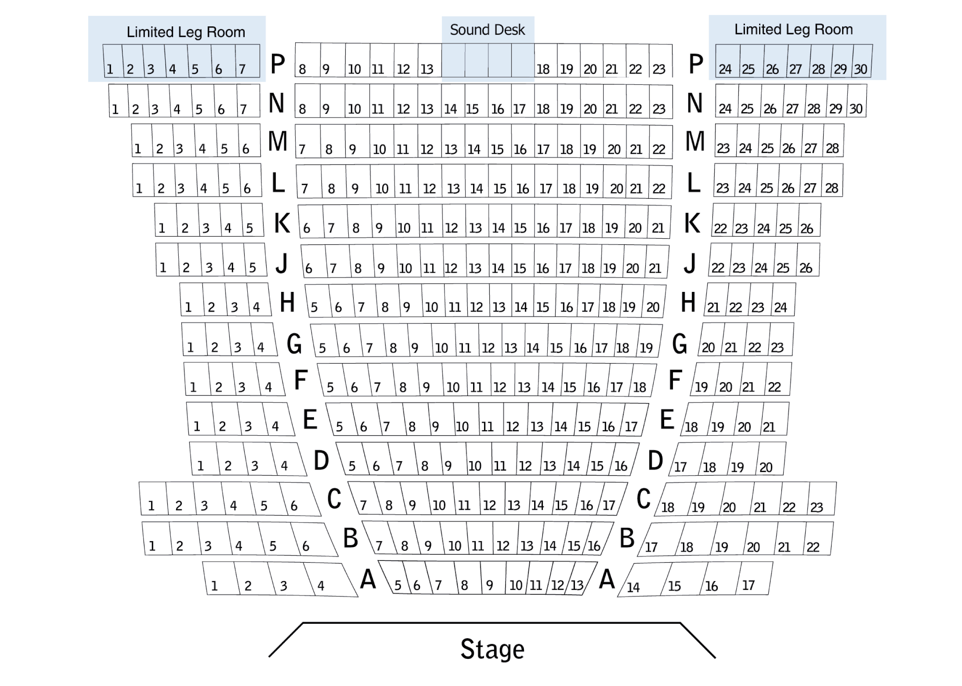
H/hire forms/ticket printing Request form.doc Last amended 16/4/2010

